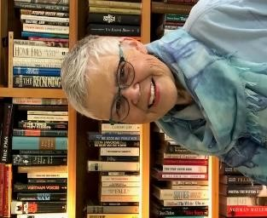
Area Liaisons’ &
Chapter Presidents’ Page
… from your State President

Happy Holidays to All of You,
May this season bring you laughter with friends and family, moments of reflection to rejuvenate, and a great appreciation of your talents and qualities that make you unique. Having been an Area Liaison for five years, I know how important that role is between chapters in that area. I am therefore including Area Liaisons as recipients of this President’s Page.
It’s exciting to learn about Literacy Projects being implemented all over the state to increase reading skills with children and adults through books. Remember that we will be sharing all chapter ideas at the state convention on April 24-25 at the Red Lion in Olympia. Please plan on attending. It is only when we share our goals and successes that we realize the impact we have in education and with our chapter sisters including the bond we have with one another.
The Presidents’ Page from our International President Cathy Daugherty is attached. Please read about the possibility of moving headquarters, registering for our International Convention in Philadelphia, and other deadlines. I encourage all of you to think about attending the convention in Philadelphia, go early to take advantage of tours and stay late to embrace such a vibrant city as part of our history. You can go online to www.dkg.org and register today. Hotel reservations can be made as well.
I have decided to add a column to the Alpha Sigma News entitled, “Books Worthy of our Time”. Please let me know of books that you or your members recommend, nonfiction or fiction. Include one or two sentences about the book. As educators, we are life long learners and the excitement of enjoying reading cannot be duplicated or understated! We encourage others to read and should enjoy the love of reading for ourselves. Several chapters devote one month a year to discussing a book previously chosen by members. Does your chapter? If not, is this a possibility?
Please read over Pat Bennett-Formans’ four A.P.P.S. in the Alpha Sigma News.: advocacy, professional development, personal well-being and service. Workshops can be built around these four areas creating a well rounded year. Also, refer to our Washington Organization Strategic Action Plan 2017-2021 which can be found in your 2019-2020 Directory. These include our mission, vision and values with goals & objectives.
Thank you for serving as leaders in your chapter, area and at the state level. You are greatly appreciated.
Gratefully, Susan Fritts, Washington State President, DKG International Society

“Leading Women Educators Impacting Education Worldwide”
“Embracing Possibilities: Leading with Wisdom and Passion”

President’s Page Newsletter 4, November/December, 2019

