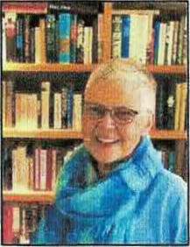
Area Liaisons', Committee Chairs' and
Chapter Presidents' Page
from your Washington State President
"Embracing Possibilities: Leading with Wisdom and Passion"
"Leading Women Educators Impacting Education Worldwide"

Newsletter 29

Dear Chapter Presidents, Area Liaisons, Committee Chairs and State Officers,
Are you preparing to attend the Portland International Conference July 7-10, 2021? What an opportunity we have to attend an international conference so close to home! There is a Travel Fund for travel stipends available to state officers, area liaisons, and presenters. I have attached the Travel request form which needs to be sent to Nancy Guthrie by June 1, 2021.
Chapter Presidents: Please send the names and e-mails of your members who are planning on attending the Portland Conference to Paula Nichols at nicholspaulam@gmail.com Paula is in the process of making reservations for dinner
at a local restaurant in Portland and needs to know how many members from Washington will attend Friday evening on July 9th.
Please be mindful of the dates of events listed below. Hope to see you in Portland!
Again, I value each of you. I thank all of you for your service during this pandemic.
Gratefully, Susan Fritts, 2019-2021 Washington State President, DKG Society International

Events:
- July 7-10, 2021 International Conference, Portland, OR
- October 2-3, 2021 Fall Board, Yakima Red Lion (Saturday and Sunday)
- May 13-15, 2022 State Convention, Hotel Red Lion Olympia
- June 21-23, 2022 Rainbow Lodge
- July 12-16, 2022 International Conference 2022, NOLA
- Sept. 23-24, 2022 Fall Board, Yakima Red Lion (Friday and Saturday)
- April 27-28, 2023 State Convention, Hotel Red Lion Olympia
- June 27-28, 2023 Dumas Bay

