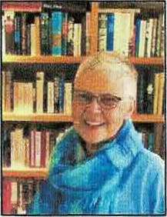
Area Liaisons', Committee Chairs' and
Chapter Presidents' Page
from your Washington State President
"Embracing Possibilities: Leading with Wisdom and Passion"
"Leading Women Educators Impacting Education Worldwide"

Newsletter 23

Dear Chapter Presidents, Area Liaisons, Committee Chairs and State Officers,
A huge thank you for continuing to connect with your DKG sisters. By now, your daily routine has most likely been established. It feels good to have control over your surroundings even though the pandemic continues to rage, vaccinations may be hard to get appointments, and the Inauguration of a new administration will occur in two days. Thus, we cannot always control what’s happening, but we must do the best we can.
A webinar sponsored by the United Nations provides an opportunity for you and your members to learn more about Indigenous Peoples: Advocating for Education. I have attached the letter indicating how you can register. A reminder to Area Liaisons that we will meet via Zoom on Wednesday, January 20th at 5pm. I sent a link yesterday with the ID and passcode.
The Executive Committee is in the process of preparing for our State Convention. In a normal year, we would plan to meet in Olympia at the Red Lion Olympia on April 30-May1st. However, with COVID19 and the rate that vaccinations are being given, we are not sure whether that is an option. So, we are planning for both. If we cannot meet in person, we will have a Virtual Zoom State Convention that will be presented from April 26th-May 1st, 6 days. The next issue of the Alpha Sigma News will display our workshops with descriptions and a general outline for each day.
Have a wonderful week. Treat yourself to something, that fills your need for fun (laughter provides such positive results), work on something you are good at (power), show freedom to do something in your life, and connect with someone you LOVE. Fun, Power, Freedom, and Love are needs we must fulfill in our lives for a well-balanced life. How are you doing?
Gratefully, Susan Fritts, Washington State President, DKG Society International

