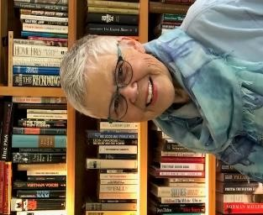
Area Liaisons’, Committee Chairs’, State Officers,
& Chapter Presidents’ Page
…from your Washington State President
“Embracing Possibilities: Leading with Wisdom and Passion”
Newsletter 22

Dear Chapter Presidents, Area Liaisons, Committee Chairs and State Officers,
Happy New Year! This time of year, is usually filled with hygge (pronounced hoo-gah) which is a Danish expression meaning “feeling good, cozy, comfortable, that engenders a feeling of contentment”. Baking special cookies and fixing holiday dishes, selecting perfect gifts for loved ones while embracing the cheer and laughter of family and friends have historically helped us to celebrate Christmas and the new year. Now this holiday scene has been replaced by online gatherings, calls, e-mails and text messages. We find joy in other ways. How do you find joy? How have you created your own hygge? Please e-mail me ways that you have found joy or your favorite pastime during this pandemic. How are YOU coping? sdfritts@comcast.net
One workshop you may be interested in is “Mental Health: Impact, Legislation & Resources for WA Families and Communities”, online Jan. 5th from 5:30-6:30pm.
International President Becky Sadowski has sent an update regarding the sale of the headquarters building in Texas. Please read her message.
Have a wonderful New Year’s Eve and Day!
Gratefully, Susan Fritts, WA State President, DKG Society International

Dates to Remember:
- January 5th Mental Health Seminar: See flyer
- January 9th Executive Committee Meeting
- January 10th`Budget Meeting
- January 11th Executive Board Meeting (Chapter Presidents, State Officers)
- January 15th Nominations for state officers are due
- January 20th Area Liaison Meeting 5-6pm
- February 1st Achievement Award application deadline
- March 15th State Officers/Committee Chair reports are due
- July 7-10th International Conference in Portland
- July 15th Chapter Treasurer annual report due
- Feb. 15, May 15, July 15, October 15 – deadlines for Alpha Sigma News

