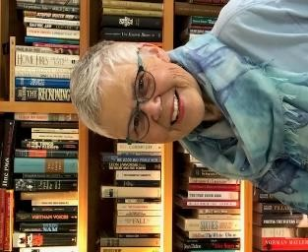
Area Liaisons’ &
Chapter Presidents’ Page
… from your State President
“Embracing Possibilities: Leading with Wisdom and Passion”
Newsletter 11

Dear Chapter Presidents and Area Liaisons,
Washingtonians are well into the COVID19 Pandemic Mode of survival; “Stay Home, Stay Safe”. Recent headlines in the Seattle Times and NY Times tell the story:

“Distance and Separation” “Forced to Adapt” “International Exposure, Without the Travel”
“Changing Course” “Giving In to Letting Go” “Bring the World with You”
“We are all in this Together” “Stay In, and See What’s Out There” “It Won’t be like this Forever”

Even the comic strips in newspapers are finally catching up with the pandemic showing how we can laugh at changing social behaviors that now seem to be part of our norm. Our persistence to wash hands for 20 seconds, wear masks when with others, and have as little contact with groups as possible is our way to survive.
How has YOUR world changed? My hair is longer, I try new recipes and crafts or projects, my gardens are looking colorful while vegetable seeds have begun to germinate, and a squirrel has befriended me. There is a down side; I find myself becoming anxious when I shop for groceries, and sometimes more apprehensive when driving. Yet it is an adventure to mail a letter at the post office, talk with families while on a walk, or set up a cocktail hour with a couple next door. My reality is filled with mixed emotions but we must deal with them often by talking with others.
Connecting with DKG members is so important. Letting them know you care about them helps everyone to be more grounded. There are many ways DKG members can impact education and personal growth while at home. Those of you who are teaching, your role with students must be acknowledged and admired; keep up your support helping students to make connections while continuing to set goals and learn. As DKG members, we can learn a new skill such as how to create a newsletter letting members know how other members are doing or design a website. This would be a good time to review proposed amendments to our state and governing documents sharing your opinion with members. With new officers being installed, what ways can you excite members and encourage educators to join? How can you adjust your connections with members from a safe distance? Sending out names of World Fellowship recipients so each member can write or e-mail an individual would be an excellent way to support young women in their education. I’ve attached Barb Clausen’s letter on World Fellowship.
On April 25th, the Executive Board (chapter presidents and state officers) plus other members met on a Zoom Conference Call. Thank you for taking time to join us. It is important to make Society Business decisions and this new venue seemed to run smoothly and efficiently. We had over 60 members online. Minutes are attached.
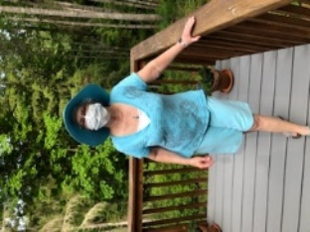
As you take advantage of time at home, please remain steadfast in your commitment to DKG as well as your daily habits to maintain health, safety and wellbeing.

Gratefully, Susan Fritts
Washington State President, Delta Kappa Gamma Society International

