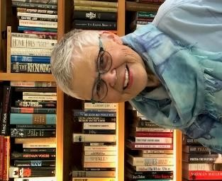
Area Liaisons’ &
Chapter Presidents’ Page
… from your State President
“Embracing Possibilities: Leading with Wisdom and Passion”
Newsletter 8

Dear Chapter Presidents and Area Liaisons,
Governor Jay Inslee has decreed that the state of Washington be in a Medical Emergency! Although we may recognize symptoms, we do not have a vaccine developed to counter the effects of this virus. The best way to prevent illness from this virus is to avoid being exposed. Therefore . . .
The decision has been made! It is with heavy hearts that we have canceled our Washington State Convention scheduled for April 24-26, 2020 at the Olympia Red Lion due to the increase in cases of coronavirus, also known as COVID-19. We, the Executive Committee of Washington State, made this decision to cancel based on several factors: the most vulnerable victims of the coronavirus are those people over 60 years of age, becoming most vulnerable for 80 years and older, if you have pre-existing conditions such as diabetes or a heart condition or are susceptible to respiratory problems like pneumonia or bronchitis, being aware of “social distancing” which means keeping a distance of six feet or more. If we abide by these conditions, we just cannot hold our state convention. Many of our DKG members are over 60 years of age, have pre-existing conditions, and workshops and meals do not allow for members to sit 6 feet from each other. Another consideration is that some of us may be carriers of the COVID-19, but we wouldn’t necessarily show symptoms for two weeks. Everyone has a role to play in getting ready and staying healthy. Our members come from all over the state. We need to be responsible citizens to make the right choice. Therefore, we have the safety and health of all DKG members that drives our decision.
If you booked a room, please don’t call the Red Lion. Paula Nichols, State Executive Secretary, is in communication with the staff. She will let me know the process you should go through. If you registered for the convention by sending your check to State Treasurer Pat Russell, she will contact you via e-mail or phone. You can always e-mail me at sdfritts@comcast.net or call 206-780-3665.
Those of you who were presenting workshops or presiders a the workshops or at meals, I will be getting in touch. We may either place some workshops on the webpage (www.dkgwa.org) so you can enjoy them or we will present them at Fall Board in September. We have received updates from International and may be able to view Dr. Helen Popovich’s keynote speech at a later date.
We recognize that we are the first in our DKG state’s history to cancel a convention. However, we understand the importance of taking these actions now to reduce further transmission in Washington State. We all make a difference!
Gratefully, Susan Fritts, Washington State President

