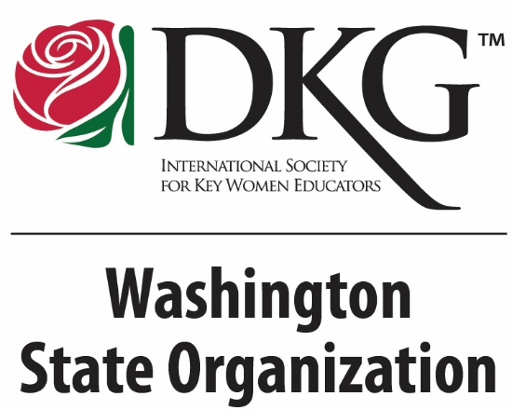
Why Join?

Members enjoy fellowship with other
professionals locally, throughout the state,
and worldwide. They participate in
community service projects and have the
opportunity to attend professional
conferences. Funding opportunities for
professional development, projects, and
scholarships for graduate study are available
at local, state and international levels.

Opportunities
through DKG
- Leadership:
  - Leadership training at local, state,
and international levels
- Professional Development:
  - Clock hour and STEM/STEAM workshops
- Travel & Networking:
  - International speakers, conventions, conferences and area workshops
- Financial Assistance:
  - Scholarships, emergency funds and educational foundation grants.
- Activism/Service:
  - UN/UNICEF projects, Schools for Africa, legislative advocacy/training.
- Publishing:
  - WA State DKG News, DKG Bulletin,
Collegial Exchange
- Recognitions:
  - Achievement Awards, Outstanding
Educators, Juried Fine Arts Gallery

International – www.dkg.org
Washington State – www.dkgwa.org
State Facebook Page - @WAStateOrganizationDKG

Chapter
information

Website –

Facebook Page –

Email Address –

Chapter Name
City, State

Our Members

Information About the Chapter:

Who is the DKG key woman educator?
DKG members are educators in any field or
level of education PS-university; public or
private; active or retired; classroom teachers,
nurses, specialists, therapists, administrators, professors, college education majors and others. A DKG member is an exceptional
educator who is:
  - A current or potential leader
  - Committed to excellence in education
  - A life-long learner
  - Results oriented
  - Authentic
  - Service oriented
  - Motivated to make a difference
  - Supportive of children’s issues
Programs & Projects

Chapter Programs & Projects:

Chapter Activities:

Chapter Fundraisers:

Chapter Meeting
Information

Chapter Meeting Dates & Location(s):

